Snapchat (minimum age is 13)

Snaps are only shown for a brief time and seem to be gone, however, Screen shots can be taken and user will be notified.
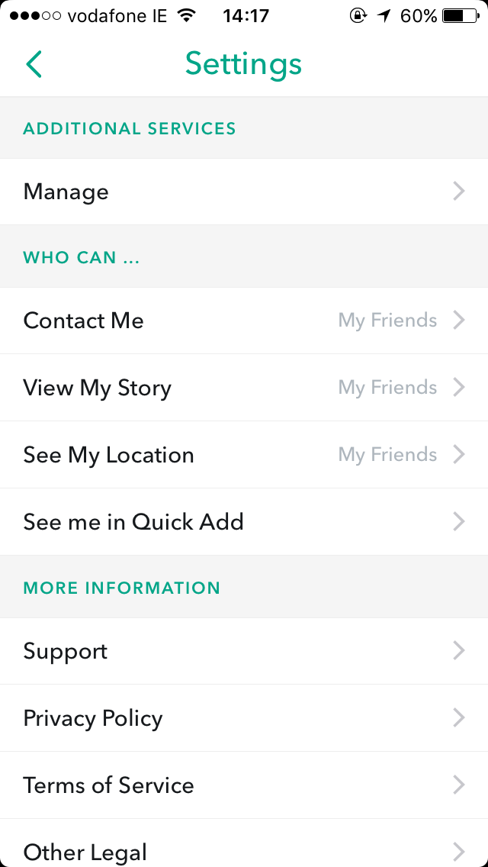
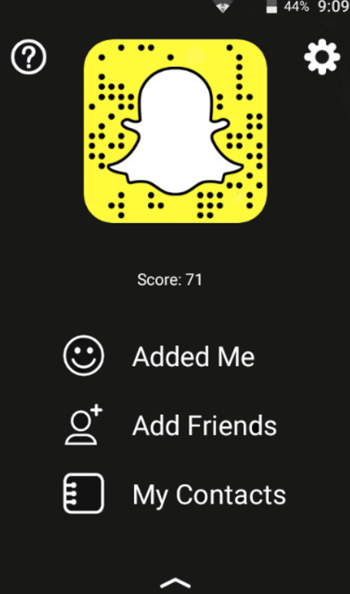
- Choose the settings icon ( see image )
- Change Who can settings to
- Contact me > My Friends
- View my story > My Friends/Custom
- See me in Quick add > turn off

- See my Location > Ghost mode

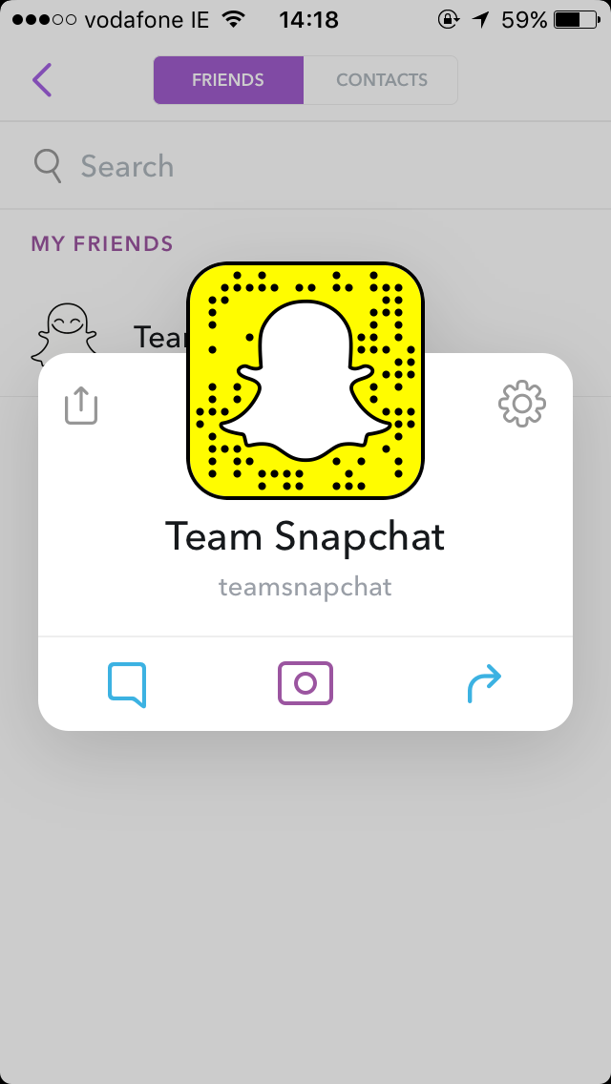
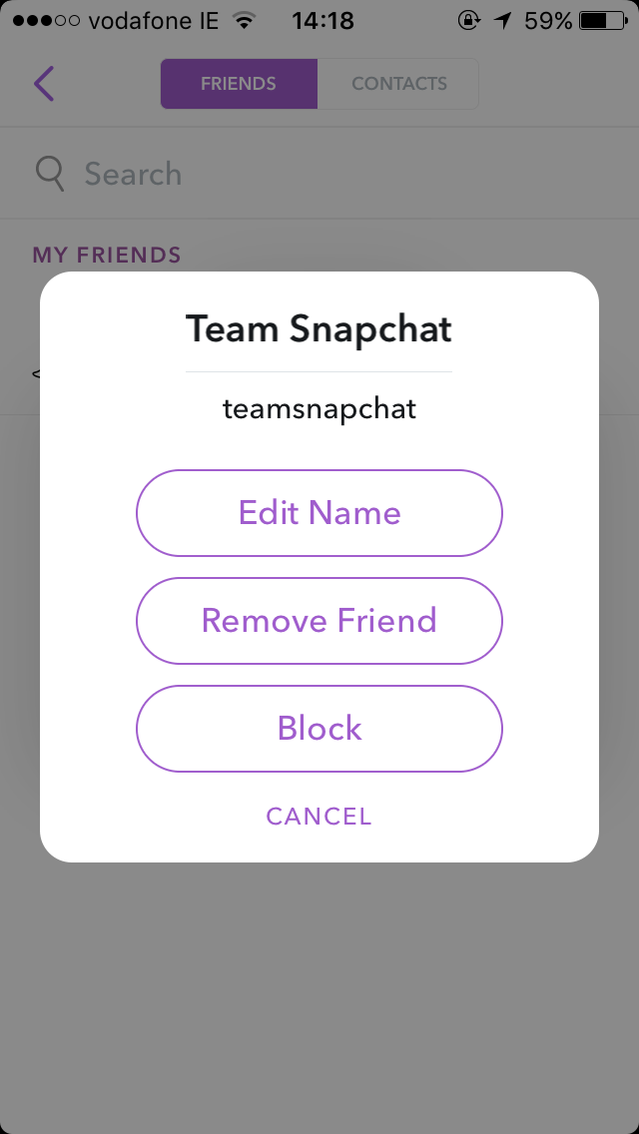
- To BLOCK other users > choose my friends > find the user you want to block, press their name. Choose the settings icon (see image) and select BLOCK. Confirm this by selecting BLOCK again.

___________________________________________________________________________

Instagram (minimum age is 13)
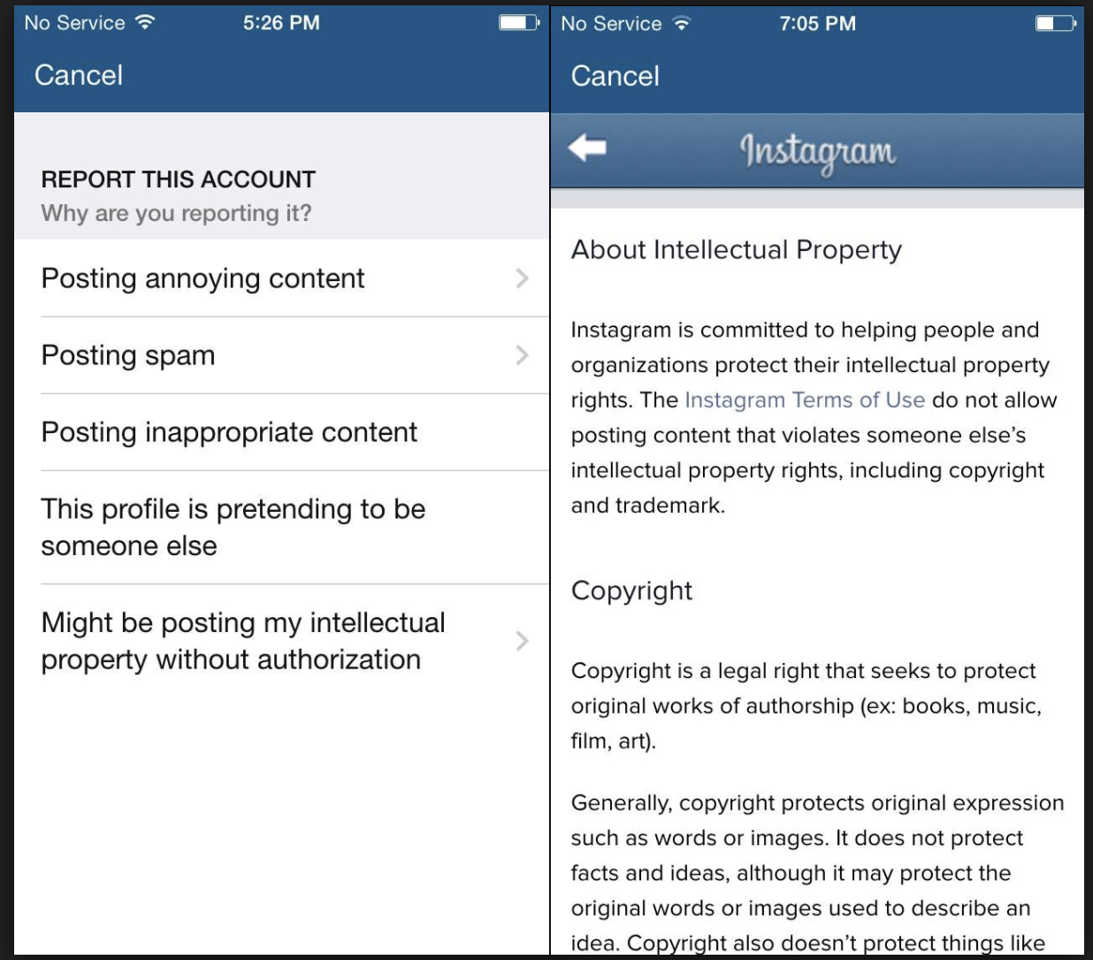
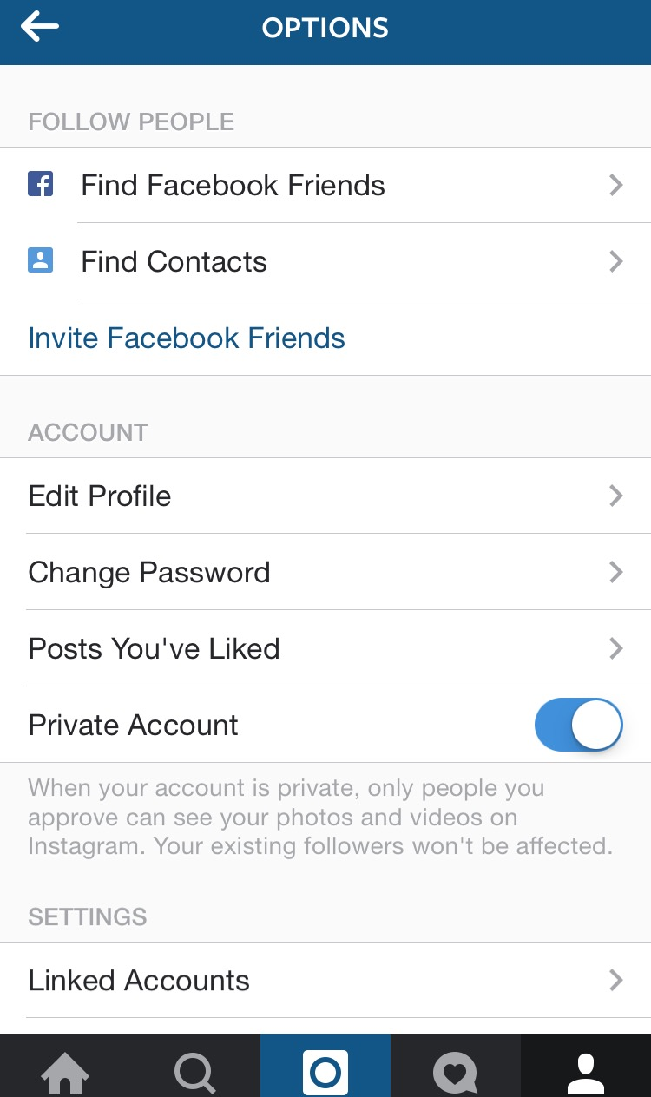
- You can REPORT an image by clicking on the … (3 dots) and choosing Report. You will then be asked to choose why you wish to report the image.

- You can REPORT an account in the same way by going to the user profile and selecting the … (3 dots) and choosing REPORT. As seen in the image, you will be asked to state your reasons.

- You can BLOCK someone and they won’t be notified. Tap their username and open their profile. Tap … ( 3 dots ) in the top right corner > choose BLOCK. Choose BLOCK again.

- Set account to Private > Click settings icon and scroll to private account. Slide to the right to turn on this option.
Facebook (minimum age is 13)

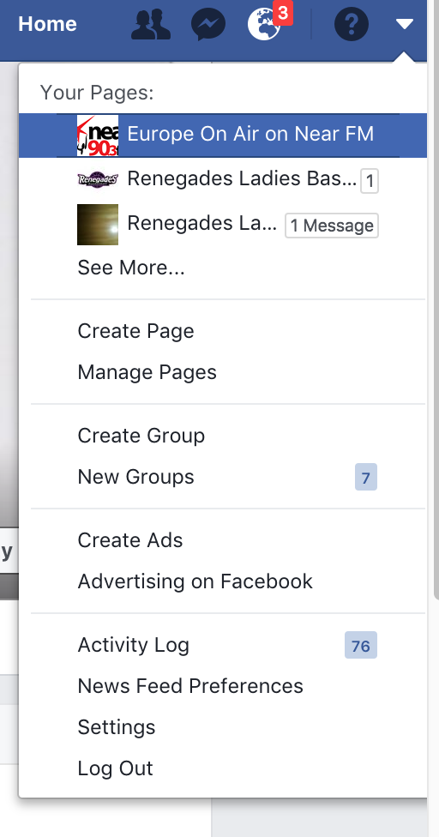
- Set privacy settings to the following:
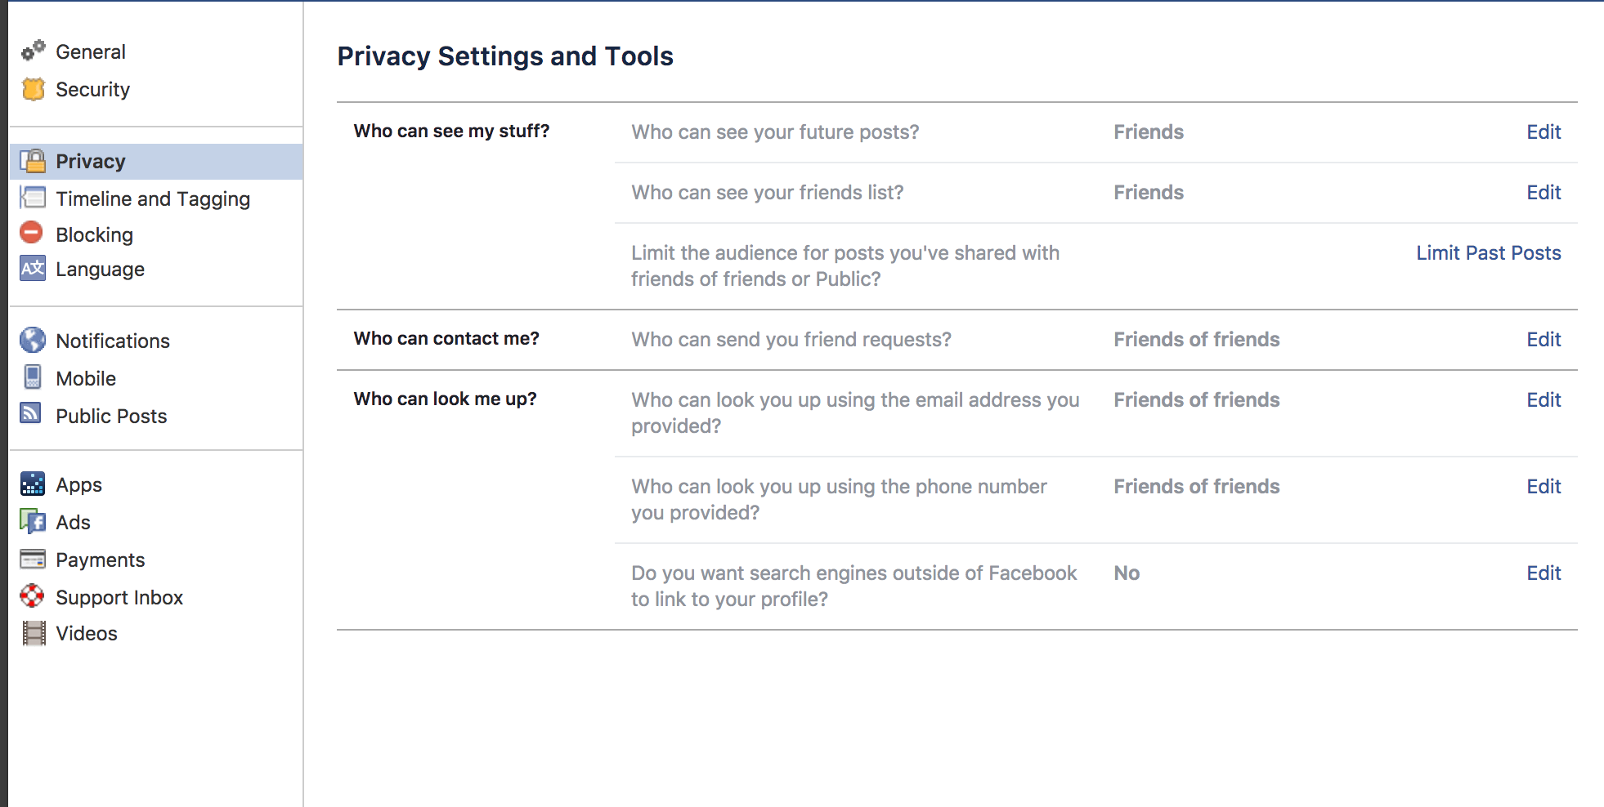

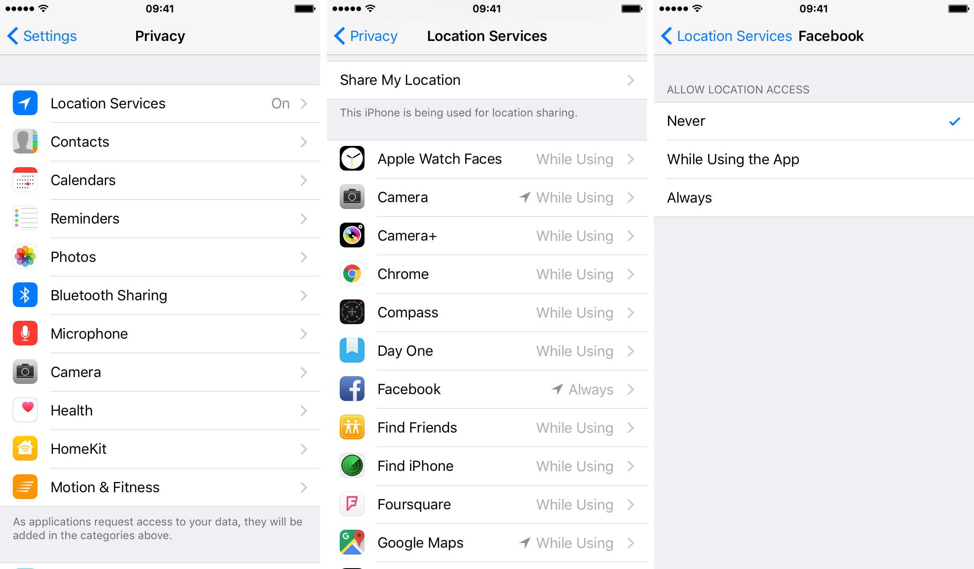
- Check that the profile image used is appropriate and doesn’t give away personal details e.g. school uniform.
- Turn off location settings so that check ins and photos do not show your location. You can change the access to NEVER by entering the Settings section of your PHONE not the APP.

___________________________________________________________________________

Twitter (minimum age is 13)

By its nature Twitter allows users to give their opinion and share their thoughts however there are some things you can do to safeguard your child’s use of this app by visiting the privacy settings as shown below:
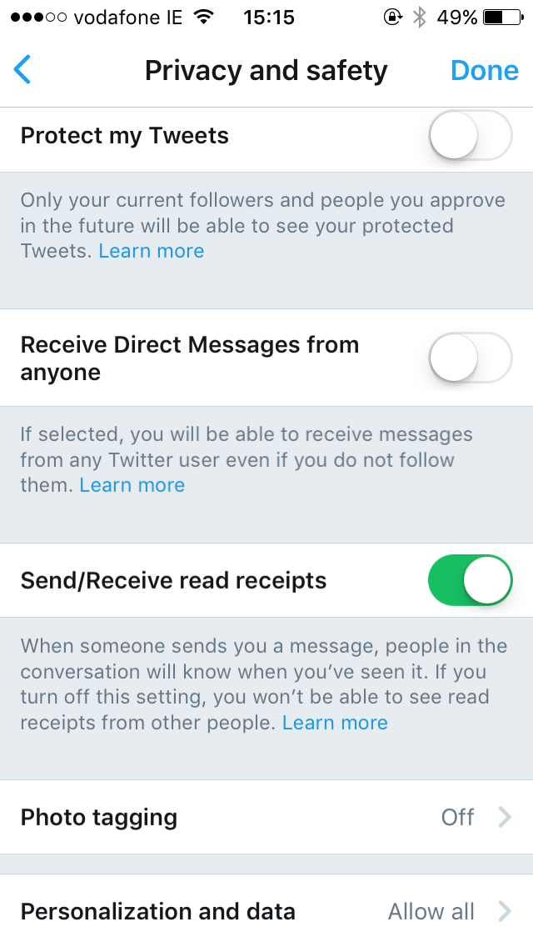
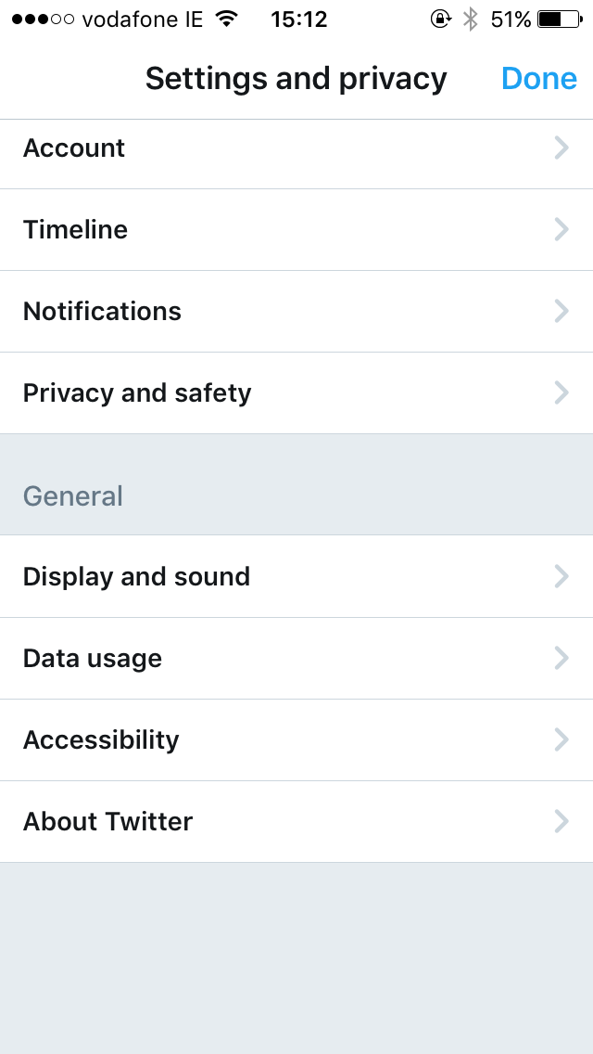
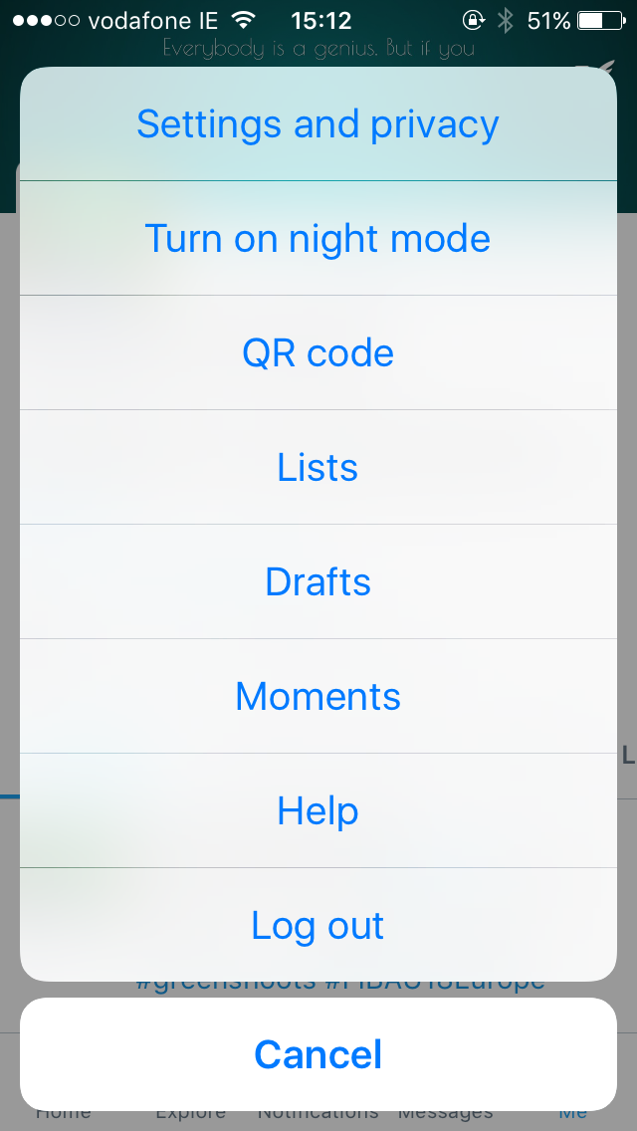
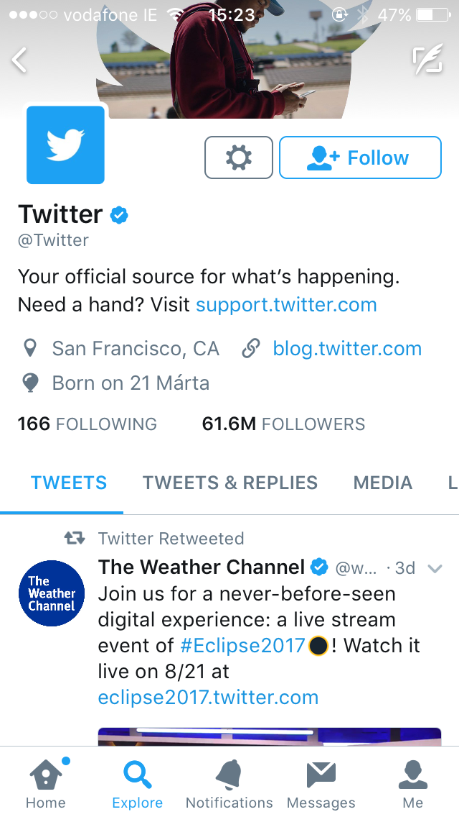
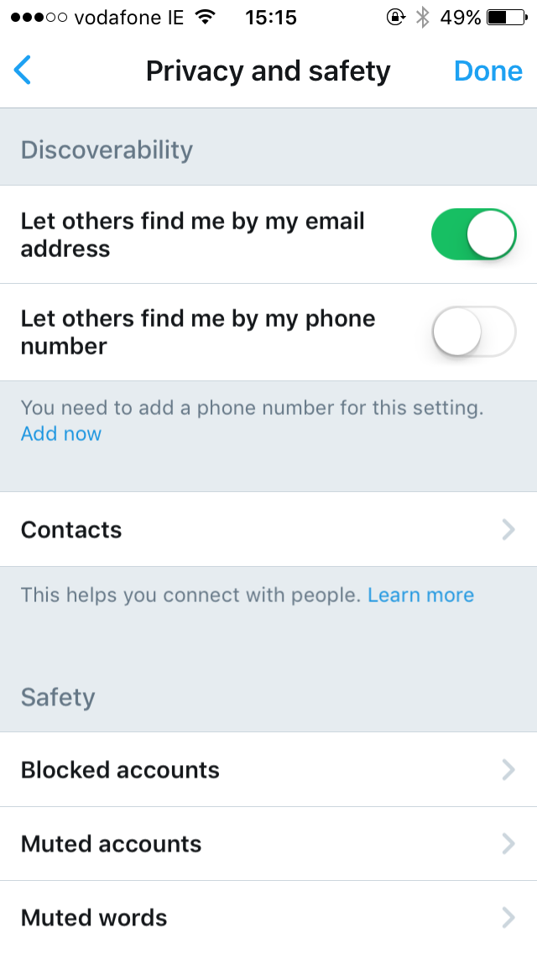

- Select Protect my Tweets so only followers can see tweets from you
- Select Phot Tagging and change the setting to People I Follow can Tag Me
- Turn off discoverability by email and phone number
- It is advised that you also turn off location services for Twitter as per the instruction above for Facebook.

___________________________________________________________________________

Talking about the apps
The above tips for social media use are a good start to safeguarding young people online, however the most effective tool is conversation and making sure your child is aware of their digital footprint and online risks. Getsafeonline.org have put together some questions for parents to get their young people talking about internet safety:

- Do you really know everybody on your ‘friends’ list?
- Do you know how to use and set privacy and security settings? Can you show me how?
- Do you ever get messages from strangers? If so, how do you handle them?
- Do you know anyone who has made plans to meet someone offline that they’ve only ever spoken to online?
- Are people in your group of friends ever mean to each other, or to other people, online or on phones? If so, what do they say? Has anyone ever been mean to you? Would you tell me about it if they were?
- Has anyone at your school, or anyone else you know, taken naked or sexy photos and sent them to other people, or received photos like that?
Some other useful websites and videos include:
- https://www.webwise.ie
- https://thecpsu.org.uk/
- https://h2bsafetycentre.com/
- www.o2.co.uk/help/nspcc/child-protection
- www.ceop.police.uk
- www.childnet.com
- https://www.saferinternet.org.uk/advice-centre/parents-and-carers

Future updates
We hope this helps and we will endeavour to keep this up to date as new apps arrive; if there is something we have missed or an app that is particularly prevalent in your club let us know and we can include it the next update.
Youth Development
August 2017

