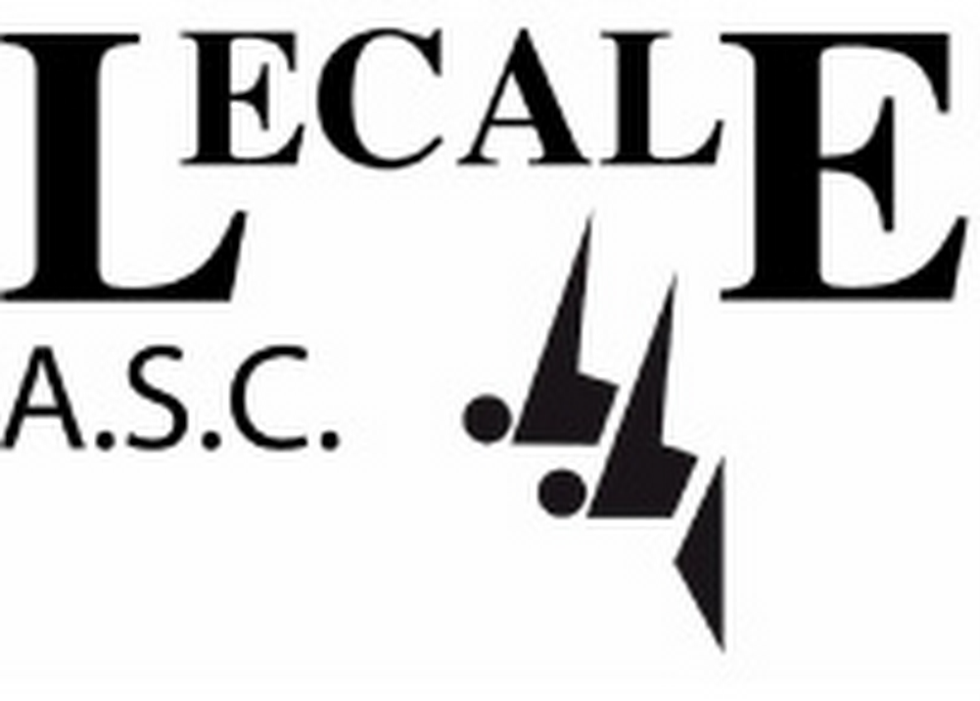NOTICE OF ANNUAL GENERAL MEETING

The management committee of Lecale ASC give notice of the club’s Annual General Meeting.

The AGM will take place on Friday 21st June 2019, starting at 7pm, in Down Leisure Centre, Downpatrick

Motions for resolution and nominations for election to the management committee must be received in writing by the club secretary no less than 7 days prior to the meeting.

Fully paid up Lecale members (both swimmers and committee officers) aged over 18 are eligible to vote. For members under 18, parents shall hold one vote on behalf of their child/children (ie one vote only, not one per child). Only one parent may vote and this must be so agreed between the parents.

The AGM will be followed by the annual awards and presentation evening.

The order of business for the AGM will be as follows:

AGENDA

1. Minutes of the AGM held on 29th June 2018

2. Presentation of the Club’s Annual Report
- Chairperson’s report
- Secretary’s report
- Treasurer’s report
- Head coach’s report
- CCO report

3. Consideration of any changes proposed to the club’s constitution

4. Consideration of any motions submitted

5. Election of the Executive Officers of the club (Chair, Treasurer and Secretary)

6. Election of 4 other Committee members

7. Election of two delegates from the club to represent Lecale ASC at Swim Ulster and Swim Ireland AGMs

8. AOB
NOMINATION FORM – CLUB EXECUTIVE OFFICERS

The Club Executive Officer positions are:

- Chairperson
- Secretary
- Treasurer

Those nominated must be members (or be prepared to become members) of the club and must agree to be bound by the Club’s Constitution, its Code of Conduct for Committee Members and the rules and requirements of Swim Ulster and Swim Ireland.

A nominee requires both a proposer and a seconder. Proposers and seconders must be members of the club in their own right or the parent of a fully paid up child member. The proposer and seconder cannot be related to the nominee and cannot both be members of the same family.

Please complete the form below:

We the undersigned wish to nominate the person named below for election to the executive position named below. We confirm that we have the consent of the nominee.

Name of person being nominated (BLOCK CAPITALS)

______________________________________________________________________

Nominated for (position): _________________________________________________

Proposer (name): __________________________________________________________

Seconder (name): __________________________________________________________

PLEASE RETURN THIS FORM, FULLY COMPLETED, TO THE CLUB SECRETARY BEFORE FRIDAY 14th JUNE

NOMINATION FORM – CLUB MANAGEMENT COMMITTEE POSITIONS

The Club Constitution requires the nomination and election of a minimum of 4 members including a vice chair

Those nominated must be members (or be prepared to become members) of the club and must agree to be bound by the Club’s Constitution, its Code of Conduct for Committee Members and the rules and requirements of Swim Ulster and Swim Ireland.

A nominee requires both a proposer and a seconder. Proposers and seconders must be members of the club in their own right or the parent of a fully paid up child member. The proposer and seconder cannot be related to the nominee and cannot both be members of the same family.

Please complete the form below:

We the undersigned wish to nominate the person named below for election to the management committee of Lecale ASC. We confirm that we have the consent of the nominee.

Name of person being nominated (BLOCK CAPITALS)

______________________________________________________________________

Proposer (name): __________________________________________________________

Seconder (name): __________________________________________________________

PLEASE RETURN THIS FORM, FULLY COMPLETED, TO THE CLUB SECRETARY BEFORE FRIDAY 14th JUNE 2018

