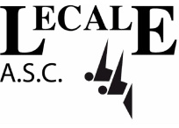

LECALE ASC

ANNUAL REPORT 2017-18

Introduction

Lecale ASC trains in Down Leisure Centre, Downpatrick and is part of the Swim Ulster and Swim Ireland families. It is a competitive swimming club which is open to swimmers aged 6 to adult.

In line with Swim Ireland requirements, the club now presents an annual report at its AGM. This report consists of:

- Chairperson’s report
- Secretary’s report
- Treasurer’s report
- Head Coach’s report
- Club Children’s Officer report

This report covers the July 2017 to June 2018 year.

1. Chairperson’s Report – by Michael Burke

1.1 I am pleased to present this report to our members and parents at the end of what has been another successful season for the club.

1.2 My thanks go to our swimmers and parents, our coaches and teachers and, particularly, to our committee members who have worked so hard this year to support our swimmers. All this hard work has provided the club with smooth and efficient running of the many aspects of work that goes on behind the scenes.

1.3 Lecale has continued with another year of great success, not only in the pool but in providing a safe and enjoyable environment for all our swimmers to try and achieve their full potential.

1.4 The club trials last September showed the continuing popularity of the club with each year we have to turn away new swimmers. This is mainly due to available pool time.

1.5 Those who swim on the Monday and Tuesday sessions will know that the club now has two sessions each night and these are structured to bring on the gala squad swimmers. During the season we also had a group of young swimmers attending Swim Ulster Talent ID training sessions in Newry LC. This has been very successful and has shown notable improvement in the skills of those attending.

1.6 Since the launch of our new Club Kit last season, there were further opportunities for membership to buy new T-shirts and Half Zip Tops. A huge thank to Pauline for organising.

1.7 In May we had our election of two new Captains for next season, namely Eimear and Philip. Congratulations to both and I’m sure they will be outstanding representatives for Lecale and great role models for our young swimmers.

1.8 This club relies on volunteers. Without the goodwill, effort and application the many tasks required to run a swimming club just would not get done. So, my thanks to all those who helped throughout the past season.

1.9 Considerable progress has been made with the new Leisure Centre development with it anticipated to open in October. We are very much looking forward to the new pool. We have been working closely with the Council/Down Leisure Centre to achieve the maximum pool time for Lecale ASC. Our current allotted time has restricted the development of the Club. More details to follow in due course.

2. ​Secretary’s Report – by Barry Nay

2.1​ Membership of Lecale ASC this season has remained very strong at 174. We aimed to keep membership near our maximum of 175 going forward unless we can increase pool time with the new pool. There are always adjustments every year; sometimes upwards, sometimes down depending on a range of variable factors.

2.2​ Every year we register with our two affiliated swimming bodies; Swim Ulster, who are the governing body of aquatic sports in Northern Ireland and Swim Ireland, who represent all members and Clubs throughout Ireland. As part of the Swim Ulster and Swim Ireland family we have to comply with the requirements of both governing bodies. We also benefit from advice and guidance on a range of governance and membership issues, including club management structures.

2.3​ Our management committee met 9 times officially throughout the year to plan our activities and to ensure compliance with the requirements of our governing bodies. Minutes of all meetings were taken and action points followed up. We also took our first steps to explore how we might achieve the Club Mark quality standard.

2.4 Club Registration will be notified to all members by E-mail but likely to take place on Friday 31st August (TBC) in Down Leisure Centre with the second and final opportunity to register, Friday 7th September. We are unclear if the pool will be open or closed in September due to the transition to the new facility. A notification will be posted on our website and Facebook page.

2.5 Info and Feedback nights was successful and we are planning two more nights in the next season. The main feedback was:
- Late +9pm pool times were not preferred by the younger swimmers
- More swim time per week would be popular

3. Treasurer’s Report – by Ann George

3.1 Income /Expenditure with an opening balance of £7438.80 and closing balance of £7877.79. Currently Membership Fees will remain the same at £170 for the first child and £150 for each subsequent child. At present the club has not been advised by NMDDC of the new pool arrangements. Fees will be reviewed subject to further notice.

4. Head Coach’s Report – by Brendan Mulholland / Eamon Magee

4.1 The Summer Prize giving last year wasn’t the start the well-earned summer break for all the Lecale Swimmers... 9 swimmers were up bright and early the very next morning to compete in the Down Minor Championships. They stormed through the competition with 17 Pbs between them and an excellent 6 Medals from Adam and Bebhionn.

4.2 In July a strong squad held the Lecale flag high: Aaron, Adam M, Isla, Jamie, Niall and Rebecca were at the Irish Age Groups Div2. The 16-18 year old boys finished an excellent 4th in both relays narrowly missing out on medals. This was backed up with a further 8 PB’s from the squad in individual events.

4.3 At the end of July Adam Colgan was at the NAC in Dublin for the prestigious IAG Div 1 age groups. Swimming in new territory Adam burst though the doors with no less than 7 entry qualifying times. Over the 5 days of competition he PD’d in every event and made the final in the 100m B/c. An awesome performance all round.

4.4 September then came with a bang, with fresh motivation and a new kit to boot featuring newly designed T Shirts, polos and half zips – by members of the 2017 D Squad!

4.5 The Development meets have been a massive success once again this year. With a squad of up to 8 swimmers travelling between venues for the 4 annual events. Results were excellent all round. With over 20 PB’s, 11 medals and many new faces; Congratulations to you all including Aidan, M, Adam M, Amy, Bebhionn, Chris, Daniel, Cormac, Mark and Niall.

4.6 The Qualifying Meets also went extremely well once again. With over 15 PB’s and 14 medals from Aaron, Adam, Isla, Jamie, Joe, Olivia, Philip and Rebecca against the best swimmers in the province.

4.7 Adam and Olivia qualified for the Ulster Age Groups in June. They both achieved new PBs, finals and top 5 finishes with a bronze medal from Adam in the 200m B/c against very tough competition.

4.9 Lecale swimmers were also on the charge at a number of other Galas throughout the year including the Bangor Minors, Templemore Minors, Ards Junior Open, Antrim Open Championships, Bangor Winter Open and The Focus Belfast Potential Commonwealth Invitational and the inaugural Swim Ulster Open Water Championships at Knockbracken Reservior, Carryduff. We had squads of up to 13 swimmers at each who collected too many PB’s to count, 30 medals, a stack of Div1 and Div2 Qualifying times, an Under 9 Top Performer trophy (Well done Aoife) and a Cash Prize for Chris!

4.10 AQUASPRINTS - This season saw 4 galas – 2 at home and 2 away. The results were as follows:
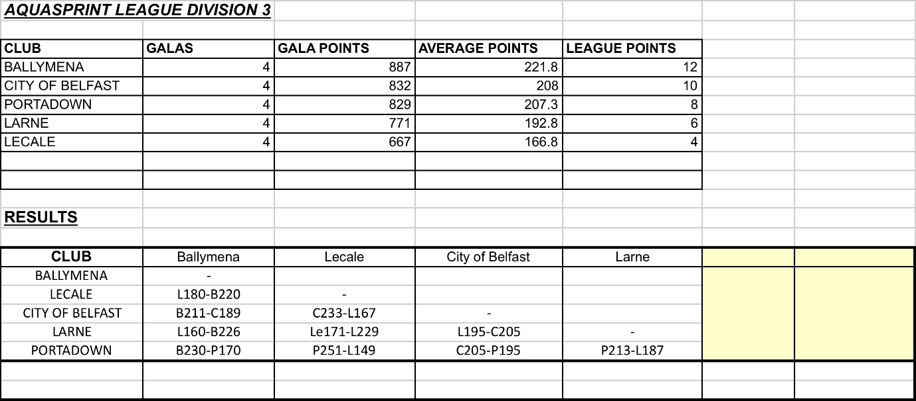

Last season the Forest Feast Aqua Sprint leagues were restructured from 4 to 5 divisions. We were promoted to division 3. There were some very close results in our galas but unfortunately, we failed to win one. As a result, we will be relegated to Division 4. Most swimmers in Clubs in Division 1, 2 and 3 train more than 4 hours per week so this really is an expected result for our Club whose youngest swimmers get 30 minutes per week in the swimming pool. This is obviously something we as a club aim to change with the new pool.

4.11 We wish to extend a very sincere thank you to all the helpers at the AS galas this year. Without you the galas would not have run as they did. The challenge of taking on organising the Aqua Sprint galas this year as well as the PTLs has been challenging for all 4 of us and we are keen to take on new AS organisers this coming season to help share the load. This year have been truly reliant upon siblings of younger swimmers to help lane marshal but this will prove difficult to maintain and we should look toward other Lecale squad members or volunteers to help out at galas. With this in mind it is our intention next season to introduce a rota system for parents and volunteers.

4.12 At each gala we need more than 20 volunteers. Roles include:

• Starter / announcer
• Timekeepers (sometimes as many as 8)
• Runners for the dockets
• Recorders at the computers
• Finish / touch judges
• Marshalls
• Stroke judge
• Referee
• Persons for assembling and serving food / teas
• Adults on the bus

4.13 – PTLs - This season saw 5 galas – 3 at home and 2 away. The results were as follows:
Date | Clubs & Scores
Sep 17 | Lecale (522 pts) v Newry (622 pts)
Oct 17 | Dungannon (566 pts) v Lecale (578 pts)
Nov 17 | Lecale (519 pts) v Swilly Seals (625 pts)
Jan 18 | City of Belfast (561 pts) v Lecale (583 pts)
Feb 18 | Lecale (587 pts) v Cookstown (577 pts)

4.14 Each year the highest performing club gets promoted to a higher division and the club at the bottom of the league drops down to a lower division in the next season – there are four divisions in total with Division 1 being the highest.

4.15 There were some very close results and we won three of our galas: against Dungannon, City of Belfast and Cookstown. As a result, we will remain in Division 2 of the PTL and our swimmers are to be congratulated on their success. Most swimmers in Clubs in Division 1 and 2 train more than 4 hours per week so this really is a massive achievement for our Club who currently has so few hours’ access to the swimming pool.

4.16 On Saturday 24th March Charlotte Savage, Bebhionn Rogan, Olivia Miskelly, Joseph McAllister and Christopher Mason represented our club at the PTL area finals in Ballymena, swimming against other clubs from the whole of Ulster, as the area heats were previously cancelled due to snow! There was a great team morale with all the Lecale team cheering each other in every race and we’re very proud to say that all five swimmers obtained top 10 places! Olivia was also placed 2nd in the 50m Back and 3rd in the 50m free and was Joseph placed 2nd in the 50m Fly.

4.17 We wish to extend a very sincere thank you to all the helpers at the PTL galas this year. Without you the galas would not have went ahead! Many parents, coaches and volunteers helped time and again and this was truly appreciated. Congratulations once again to our swimmers and coaches on their PTL success this season, and to the parents for your support.

4.18 For the upcoming IAG Div1 and Div2 competitions the entire club wishes the best of luck to our swimmers hitting the road in July in search for more PBs and swim successes against the best in Ireland.

4.19 The coaching team have already started working on the updated coaching plan for the new season. This will include rolling out of the new land training initiative ‘Strength: Lab Superheroes’ to the whole club. IN the water, we will be building in some contingency plans given some uncertainty with opening date of the new pool. However we have always got the Quoile River on standby!
We will be in touch with details when we know more.

4.20 On behalf of the coaching team, I would like to congratulate every one of our swimmers. From the youngest in the small pool to the oldest in the main pool, especially those getting ready to leave us for University next year; Thank you for all of your hard work and excellent performances throughout the year. We are very proud of you.

CCO Report – by Roisin Leckey and Fiona O’Connor

5.1 As a member club of Swim Ireland, Lecale is committed to ensuring that its young members can enjoy their swimming safe from harm and can get involved in the running of the club. The Club Children’s Officer role supports the Committee in these areas.

5.2 In swimming, there are strict requirements around the vetting of adults working in regulated positions or positions of trust with our swimmers. Enhanced disclosure checks must be carried out regularly. During 2017-18, significant effort was put into refresher training where appropriate. We attended Swim Ireland CCO training plus Safeguarding Course. Access NI checks were completed for any coaches/teachers and committee members whose clearance was due to expire. In total, there are 29 members of Lecale who have Access NI checks completed plus undertaken Safeguarding courses through Swim Ulster or Sport NI.

5.3 Our elected club captains, Aaron and Katie have been excellent role models for our younger swimmers and have given feedback on several aspects of the club. They have also welcomed visiting teams and proposed the vote of thanks during away galas. We offer our thanks to them for serving the club so well in the past year. In May we held elections for our new captains. It was great to see the enthusiasm and interest in voting among our younger members, with 143 votes being cast on election night compared to 92 last year. We offer our congratulations to Philip and Emer and I am sure they will do a fabulous job over the next year.

5.4 Finally, our young people have continued to volunteer their time and skills to help others. We now have 6 senior swimmers who have approved Level 1 or 2 Swim Ireland teaching qualifications and many others who help out on poolside and in other ways. This year Kate Mc Cauley achieved her 50 points and Aidan Mc Cauley achieved 100. Our volunteers have also registered through Swim Ulster with the Millennium Programme and during 2017-2018.

